Ski Racing Sponsorship Form

Thank you for your interest in sponsoring the Metro Ski League for the 2023/2024 season. As a sponsor, a feather flag with your company information will be displayed at the finish corral at all six Metro Ski League races. Metro Ski League races are held at Mt. Hood Skibowl, Mt. Hood Meadows and Timberline in January and February. To take advantage of the whole season, submit your information by 12/1/23.

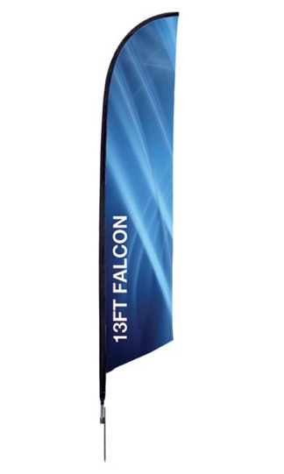
Feather flags are 13’. Sponsorship is $800.00 for the season. If you are a returning feather flag sponsor and we still have your flag, the renewal fee is $600.00. If you are interested in sponsoring a flag, complete this form and mail with payment made to Metro League Ski Racing Association.

Margie Wargo
13559 SW Hillshire Drive
Tigard, OR 97223

Questions? Contact Margie at (503) 803-3786 or at connect.metroski@gmail.com

Upon approval of your sponsorship, we will connect to discuss the layout of the flag.
_______________________________________________________________________________________

Business/Sponsor Name: ______________________________________________________
Business Address: ______________________________________________________
City/State/Zip: ______________________________________________________
Phone Number: ______________________________________________________
Email: ______________________________________________________
Date: ______________________________________________________
Check one: New Sponsor: _____ ($800.00) Renewing Sponsor: _____ ($600.00)
The Metro Ski League greatly appreciates your support. www.metroskileague.org

